Daily Family Together Activity

For each day of the week, Barningham CEVC Primary School will share one activity that families can do together. With children now spending so much time doing their learning on computers or tablets, these activities are designed to move away from the computer and bring the family together.
This is an optional activity and so does not need to be completed as part of the children’s home learning but if you would like to take part and share your activities with us, we would love to see them!

Thursday 4th March
World Book Day Audiobooks
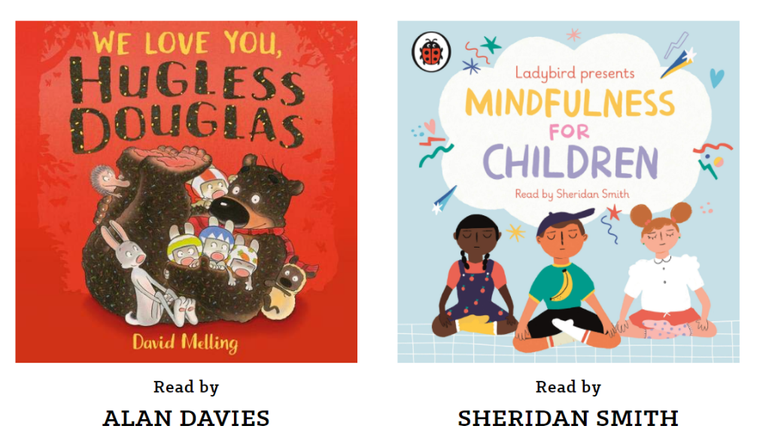
Activity: Close your eyes and listen to an audiobook to celebrate World Book Day!
For a wide range of stories, click here: https://www.worldbookday.com/world-of-stories/

What you will need: a device with access to the internet and a quiet space to listen to the stories.
Extension activities: Which is your favourite story and why?

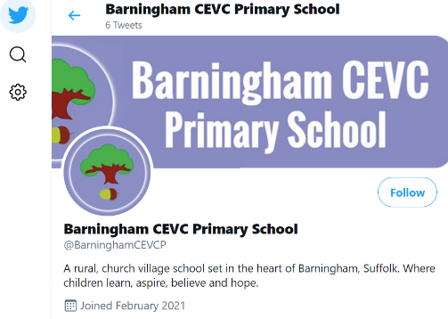
Remember to take photos of your activities and send them to us! We now have a twitter account which you can see here: https://mobile.twitter.com/BarninghamCEVCP
Please follow us and add our twitter handle to your pictures @BarninghamCEVCP
Or send your photos to the school email address admin@barningham.suffolk.sch.uk

