Daily Family Together Activity

For each day of the week, Barningham CEVC Primary School will share one activity that families can do together. With children now spending so much time doing their learning on computers or tablets, these activities are designed to move away from the computer and bring the family together.
This is an optional activity and so does not need to be completed as part of the children’s home learning but if you would like to take part and share your activities with us, we would love to see them!

Wednesday 3rd March
Make a Face Covering
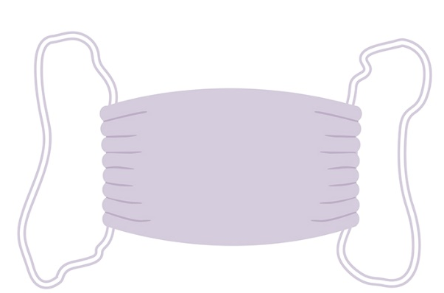
Activity: Make a cloth face covering using old cotton T-Shirts!
For full instructions, click here: https://www.gov.uk/government/publications/how-to-wear-and-make-a-cloth-face-covering/how-to-wear-and-make-a-cloth-face-covering

What you will need: an old cotton T-Shirt (or cotton material), elastic, scissors, needle and thread, ruler/tape measure

Extension activities: Use different materials – which type of material is better?

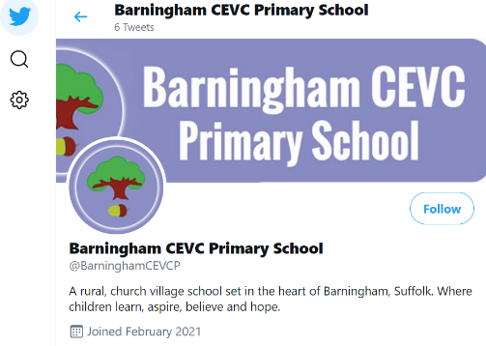
Remember to take photos of your activities and send them to us! We now have a twitter account which you can see here: https://mobile.twitter.com/BarninghamCEVCP
Please follow us and add our twitter handle to your pictures @BarninghamCEVCP
Or send your photos to the school email address admin@barningham.suffolk.sch.uk

