Daily Family Together Activity

For each day of the week, Barningham CEVC Primary School will share one activity that families can do together. With children now spending so much time doing their learning on computers or tablets, these activities are designed to move away from the computer and bring the family together.
This is an optional activity and so does not need to be completed as part of the children’s home learning but if you would like to take part and share your activities with us, we would love to see them!

Thursday 25th February
Curious Keys
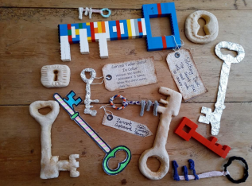
Activity: Come on a journey with us and create your very own magical key! Think about what it can open? Where can it take you? What can it do?
Find out more information here:
https://drive.google.com/file/d/10inAcM9ZXf4GSij6rlW-KBRhkL6OcfJa/view

What you will need: foil, cardboard (empty cereal packets/delivery boxes), lego, paper, pens, paint

Extension activities: What different materials can you use to make your key?
What makes it stronger?
Write a story about your key – what can it do?

