Daily Family Together Activity

For each day of the week, Barningham CEVC Primary School will share one activity that families can do together. With children now spending so much time doing their learning on computers or tablets, these activities are designed to move away from the computer and bring the family together.
This is an optional activity and so does not need to be completed as part of the children’s home learning but if you would like to take part and share your activities with us, we would love to see them!

Wednesday 24th February
Fruit & Veg Pattern Printing
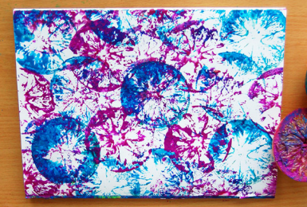
Activity: Use the patterns you find at home to inspire a print using vegetables and fruit.
Squeeze some paint onto an old plate/paper plate – have different colours ready.
Please ask an adult to help you cut the fruit/veg into half.
Dip your fruit/veg into the paint. Make patterns onto your paper using different ingredients!

What you will need: paper, fruit or veg e.g. potato, apple, orange, mushroom, carrot, broccoli, lemon, cauliflower. Paints, a knife, an adult to help you cut the fruit/veg, paper plate/old plate.

Extension activities: What different shapes do different fruits make?
Can you create a piece of art work using different coloured paints and different fruit?
Which fruit are the best? Why do you think this is?

