Daily Family Together Activity

For each day of the week, Barningham CEVC Primary School will share one activity that families can do together. With children now spending so much time doing their learning on computers or tablets, these activities are designed to move away from the computer and bring the family together.
This is an optional activity and so does not need to be completed as part of the children’s home learning but if you would like to take part and share your activities with us, we would love to see them!

Tuesday 23rd February
Kitchen Curling
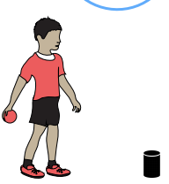
Activity: In this activity, you’re going to be trying to get as close as you can to a target to score points! Watch this https://www.youtube.com/watch?v=7051Y5duZJA to find out more!
- Clear a space on a smooth surface i.e. a table or hallway floor and place a target at one end of the space.
- Using a pair of rolled up socks, slide them across the floor, trying to get them as close to the target as possible.
- Play against an opponent. Each player has three pairs of socks. The pair of socks closest to the target scores a point.
- The player with the most points after three rounds is the winner

What you will need: pairs of socks, a smooth surface, an object to act as a target, paper and pen.

Extension activities: 