Daily Family Together Activity

For each day of the week, Barningham CEVC Primary School will share one activity that families can do together. With children now spending so much time doing their learning on computers or tablets, these activities are designed to move away from the computer and bring the family together.
This is an optional activity and so does not need to be completed as part of the children’s home learning but if you would like to take part and share your activities with us, we would love to see them!

Friday 12th February
Pancake Practise
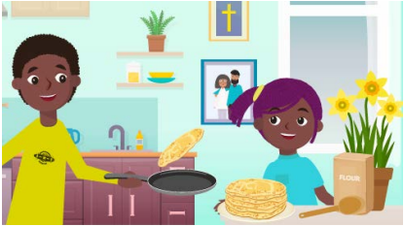
Activity: Practise making pancakes in time for Shrove Tuesday (Tuesday 16th February).
- Sieve the flour into a bowl,
- Add the egg, milk, salt and stir carefully.
- When all the flour is mixed in, whisk until you make a smooth batter.
- Heat some oil into a pan with an adult. When the oil is hot, carefully pour the batter into the pan to cover a thin layer on the bottom of the pan.
- When it is cooked, toss the pancake to cook the otherside.
- Slide the pancake onto a plate and add your favourite toppings!
Full recipe can be found here: https://bam.files.bbci.co.uk/bam/live/content/zm8df4j/pdf

What you will need: 100g flour, 1 egg, 280ml milk, salt, oil for frying, adult support for the hot pan.

Extension activities: This recipe makes around 6 pancakes. How could you change it to make 12?
What different toppings could you add?
What if you wanted to make a savoury pancake? What could you add?

