Daily Family Together Activity

For each day of the week, Barningham CEVC Primary School will share one activity that families can do together. With children now spending so much time doing their learning on computers or tablets, these activities are designed to move away from the computer and bring the family together.
This is an optional activity and so does not need to be completed as part of the children’s home learning but if you would like to take part and share your activities with us, we would love to see them!

Thursday 11th February
Long Line Stories
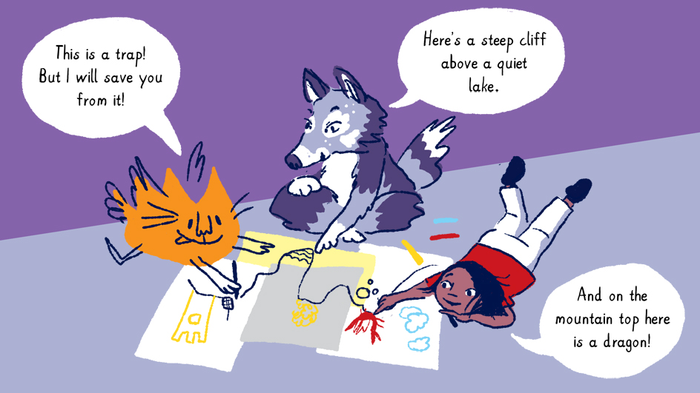
Activity: You can begin a story with only one long line… work as a family to see if you can create a family story.
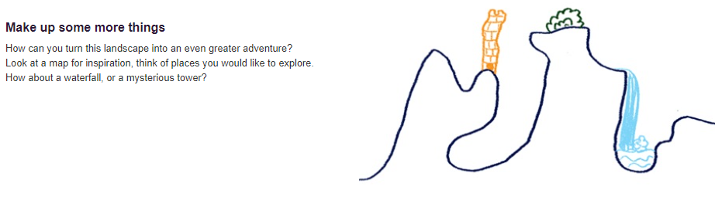
What you will need: paper, pens/pencils/felt tips, your ideas 😊
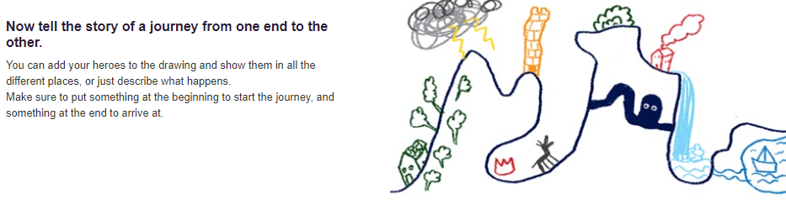
Extension activities: Write a story that matches the family picture you have created.
Split the story into sections and get each person to act out the story.
Video call friends/family who you haven’t seen and share your story with them.
Make a long line story each. What makes them similar? What makes them different?

