Daily Family Together Activity

For each day of the week, Barningham CEVC Primary School will share one activity that families can do together. With children now spending so much time doing their learning on computers or tablets, these activities are designed to move away from the computer and bring the family together.
This is an optional activity and so does not need to be completed as part of the children’s home learning but if you would like to take part and share your activities with us, we would love to see them!

Tuesday 9th February
Create Your Own Snowy Forest
Activity: Detailed below
What you will need: paper, pens, pencils, felt tips/paint, scissors, old bed sheet/white surface
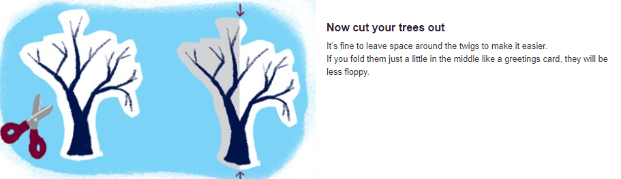
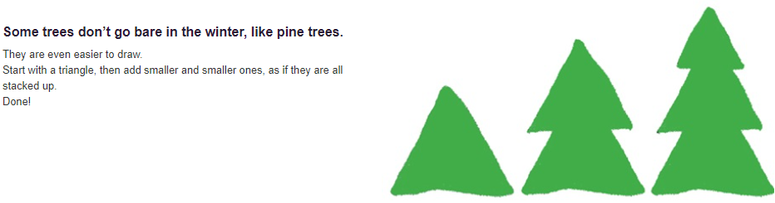
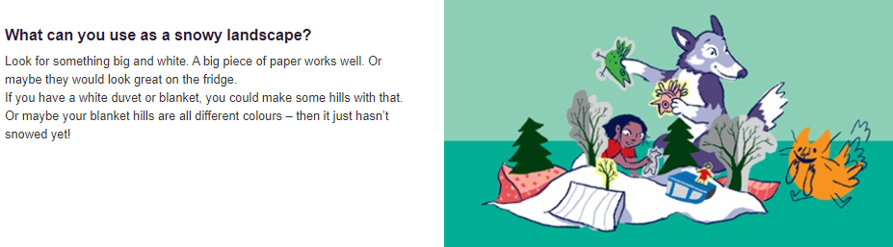

Extension activities:
