Daily Family Together Activity

For each day of the week, Barningham CEVC Primary School will share one activity that families can do together. With children now spending so much time doing their learning on computers or tablets, these activities are designed to move away from the computer and bring the family together.
This is an optional activity and so does not need to be completed as part of the children’s home learning but if you would like to take part and share your activities with us, we would love to see them!

Monday 8th February
Snow Experiment
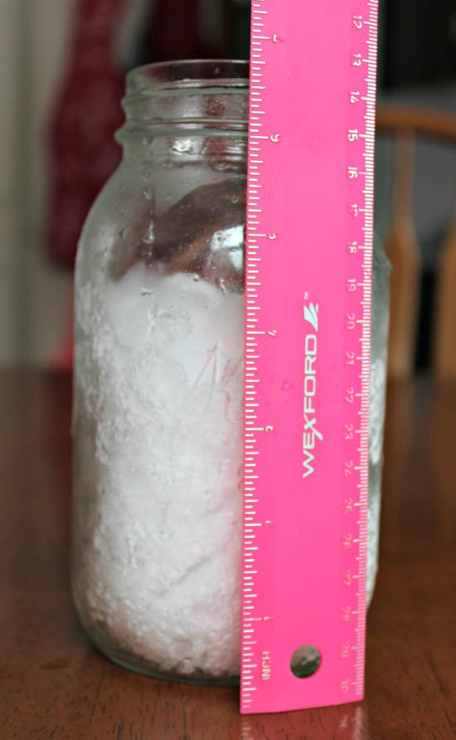
Activity: How much water is in snow?
- Head outside and fill a jar with snow. Make sure you pack it down so you have a nice amount
- Mark your snow line with a pen or a sticker on your jar. (Your jar may be very wet because of the condensation, so you can use a hair band or elastic band if the pen isn’t working)
- Use your ruler to measure the height of the snow in your jar. (You can download a ruler app on a phone/tablet if you don’t have one at home.)
- Write down the time and measurements on a piece of paper.
- Make a prediction! How much water will there be? How long will it take?
- Wait! This will take some time for the snow to melt so go and do other activities and come back to check every 30 minutes 😊

What you will need: a jar/bottle cut open to collect some snow, a ruler, paper, pen, a clock.

Extension activities: Make a prediction before you begin. How much water do you think the snow will be? Get each member of your household to write their prediction and see who is right at the end.

