Daily Family Together Activity

For each day of the week, Barningham CEVC Primary School will share one activity that families can do together. With children now spending so much time doing their learning on computers or tablets, these activities are designed to move away from the computer and bring the family together.
This is an optional activity and so does not need to be completed as part of the children’s home learning but if you would like to take part and share your activities with us, we would love to see them!

Friday 29th January
Big Garden Birdwatch
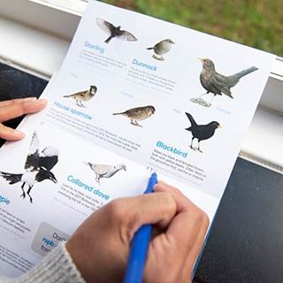
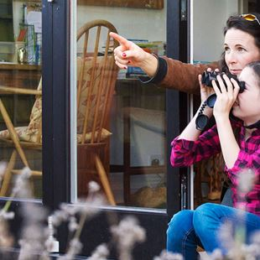

Activity: Pick a time to sit in your garden or outdoor space / overlook a green space from a window for 1 hour and note down which birds you can see. Count the birds you see in your garden or from your balcony (you can use the images on the next page to help you). Ignore any birds that are still in flight. To avoid double-counting, just record the highest number of each bird species you see at any one time – not a running total.

What you will need: Paper, pens, warm clothing, bird guide (optional on next page)

Extension activities: You can submit your results online at www.rspb.org.uk/birdwatch from 29 January until 19 February.
How many different birds did you spot?
Can you sketch an image of one of the birds you saw?
What bird is the most common in your garden?
Which bird do you want to come to your garden more? Research how to make a friendly home for this bird to encourage it to stay.
