Daily Family Together Activity

For each day of the week, Barningham CEVC Primary School will share one activity that families can do together. With children now spending so much time doing their learning on computers or tablets, these activities are designed to move away from the computer and bring the family together.
This is an optional activity and so does not need to be completed as part of the children’s home learning but if you would like to take part and share your activities with us, we would love to see them!

Thursday 28th January
Lockdown Momento
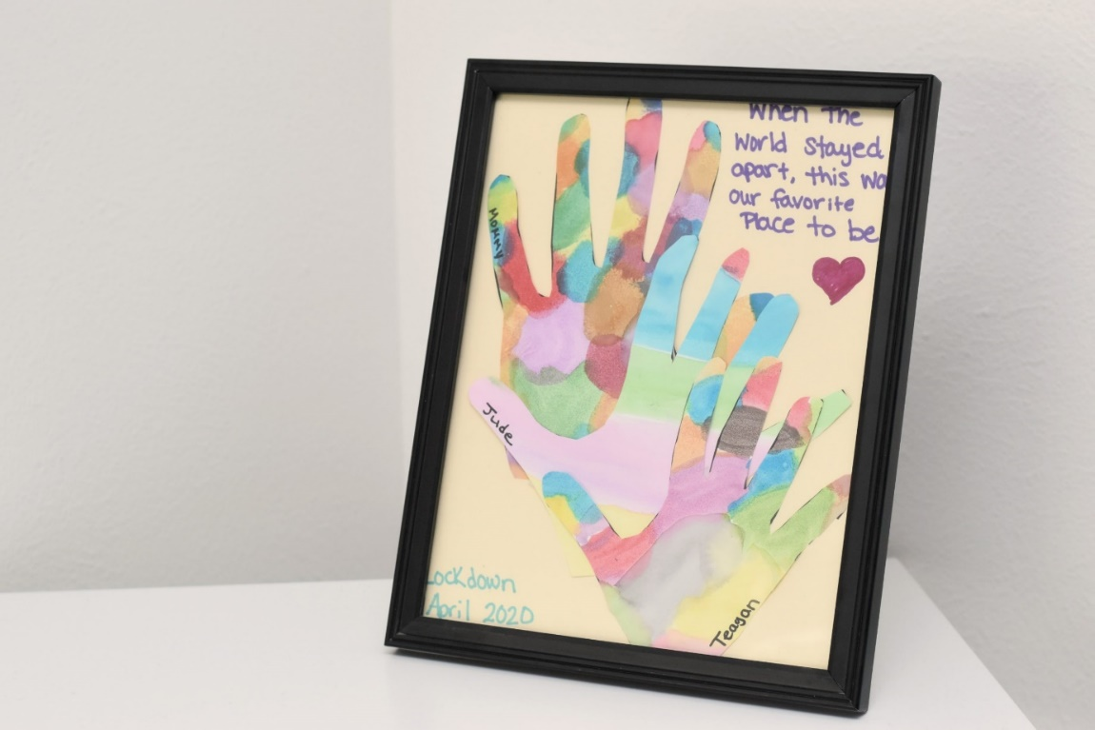
Activity: Draw around the hands of all the people in your household (including your support bubble if you have one). Colour these in or paint them and label them with who is who. Create a picture of these hands onto one piece of paper (see above) to create a memento of your time spent together as a family.

What you will need: Paper, scissors, coloured pens/pencils/paint

Extension activities: Take a photo of your momento and send it to people who you can’t see at the moment because of lockdown.
Encourage others to complete one too.
Can you design your hands in different ways? Maybe with words or memories?

