Daily Family Together Activity

For each day of the week, Barningham CEVC Primary School will share one activity that families can do together. With children now spending so much time doing their learning on computers or tablets, these activities are designed to move away from the computer and bring the family together.
This is an optional activity and so does not need to be completed as part of the children’s home learning but if you would like to take part and share your activities with us, we would love to see them!

Wednesday 27th January
Family Dance with Millie from Keep Moving Suffolk
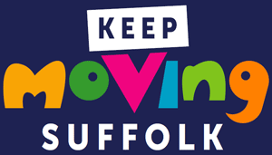
Activity: Learn a dance routine from Keep Moving Suffolk. Details below:
NEVER UNDERESTIMATE THE POWER OF EXERCISE ON YOUR CHILD’S EDUCATION
We know that supporting children that are learning at home isn’t easy. In fact, we know it’s really hard. That’s why we’ve produced this resource, to help you build exercise into your child’s daily routine. No matter what your child’s age, there is something here to help. We hope you like it, but most of all we hope you find it useful.

What you will need: Device to access the dance video here https://www.youtube.com/watch?v=U2DXxrqCPJg&list=PLMmRevvkPq3EcxigriVqsUdWxKtUPibvV&index=2&ab_channel=Suffolk-England%27sMostActiveCounty
Comfortable clothes and shoes

Extension activities: https://www.keepmovingsuffolk.com/home-schooling/ to find more ways to keep active during lockdown and when home-schooling.
How does your body feel while exercising?
How does it feel after exercising?

