Daily Family Together Activity

For each day of the week, Barningham CEVC Primary School will share one activity that families can do together. With children now spending so much time doing their learning on computers or tablets, these activities are designed to move away from the computer and bring the family together.
This is an optional activity and so does not need to be completed as part of the children’s home learning but if you would like to take part and share your activities with us, we would love to see them!

Tuesday 26th January
Design your own bridge
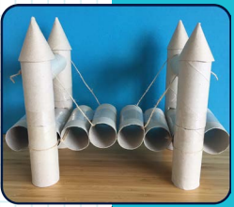

Activity: Design and make your own bridge. You can use whatever materials are available. For example, you could choose to fold paper or use kitchen roll tubes.

What you will need: Any materials you have available at home e.g. lego, toys, tubes, old delivery boxes, string, paper, kitchen towel etc.

Extension activities: How strong is your bridge?
Can it hold the weight of one coin? Two coins? Lots of coins?
Can you make two bridges? And decide which one is stronger by using coins?
Check out a further challenge on the next page using Lego!
