Daily Family Together Activity

For each day of the week, Barningham CEVC Primary School will share one activity that families can do together. With children now spending so much time doing their learning on computers or tablets, these activities are designed to move away from the computer and bring the family together.
This is an optional activity and so does not need to be completed as part of the children’s home learning but if you would like to take part and share your activities with us, we would love to see them!

Monday 25th January
Build a Tin Can Bug Hotel
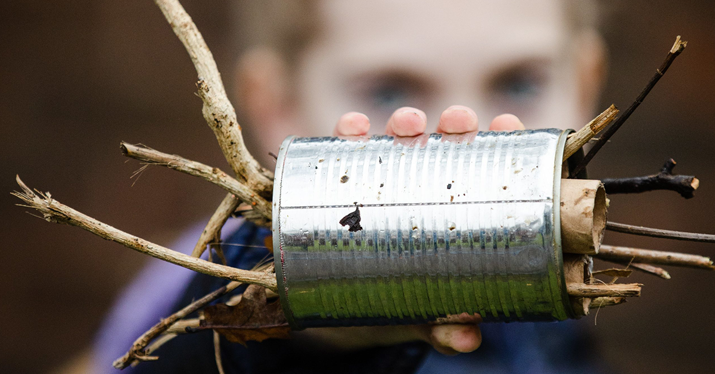
Activity: Design and make your own tin can bug hotel to attract winter bugs in your garden/outdoor space. More details can be fond here https://www.backyardnature.org/resource/tin-can-bug-hotel/

What you will need: Old tin can, washed properly, a tin opener, natural materials like sticks and bark, cardboard

Extension activities: Check the bug hotel every day – note down the different bugs you can see. Does it change each day?
Talk about why helping nature and wildlife is so important.
Make more than one bug hotel and place them in different locations.
Which locations are attracting the most wildlife? Why do you think this is?

