Daily Family Together Activity

For each day of the week, Barningham CEVC Primary School will share one activity that families can do together. With children now spending so much time doing their learning on computers or tablets, these activities are designed to move away from the computer and bring the family together.
This is an optional activity and so does not need to be completed as part of the children’s home learning but if you would like to take part and share your activities with us, we would love to see them!

Friday 22nd January
Lockdown Cards
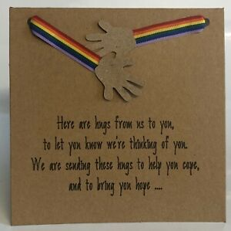

Activity: Make a card for someone in the family or a close friend who you are not able to see or who might be feeling alone during lockdown. Send this card in the post to this person if possible. If not, take a photo of the card and send it to them in a text message or email.

What you will need: Paper, pens, any other craft items to make your card beautiful.

Extension activities: Who do you think might need a card from you at this time?
What messages do people need to hear now? Especially during lockdown?
How can we help to make people feel better with our messages?
Can each member of the family make a card for different people so more can receive a card?

