Daily Family Together Activity

For each day of the week, Barningham CEVC Primary School will share one activity that families can do together. With children now spending so much time doing their learning on computers or tablets, these activities are designed to move away from the computer and bring the family together.
This is an optional activity and so does not need to be completed as part of the children’s home learning but if you would like to take part and share your activities with us, we would love to see them!

Wednesday 20th January
Make a Twig Sailing Boat
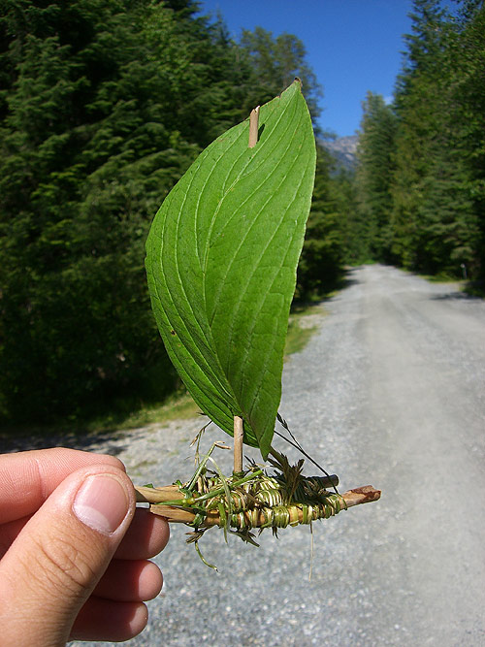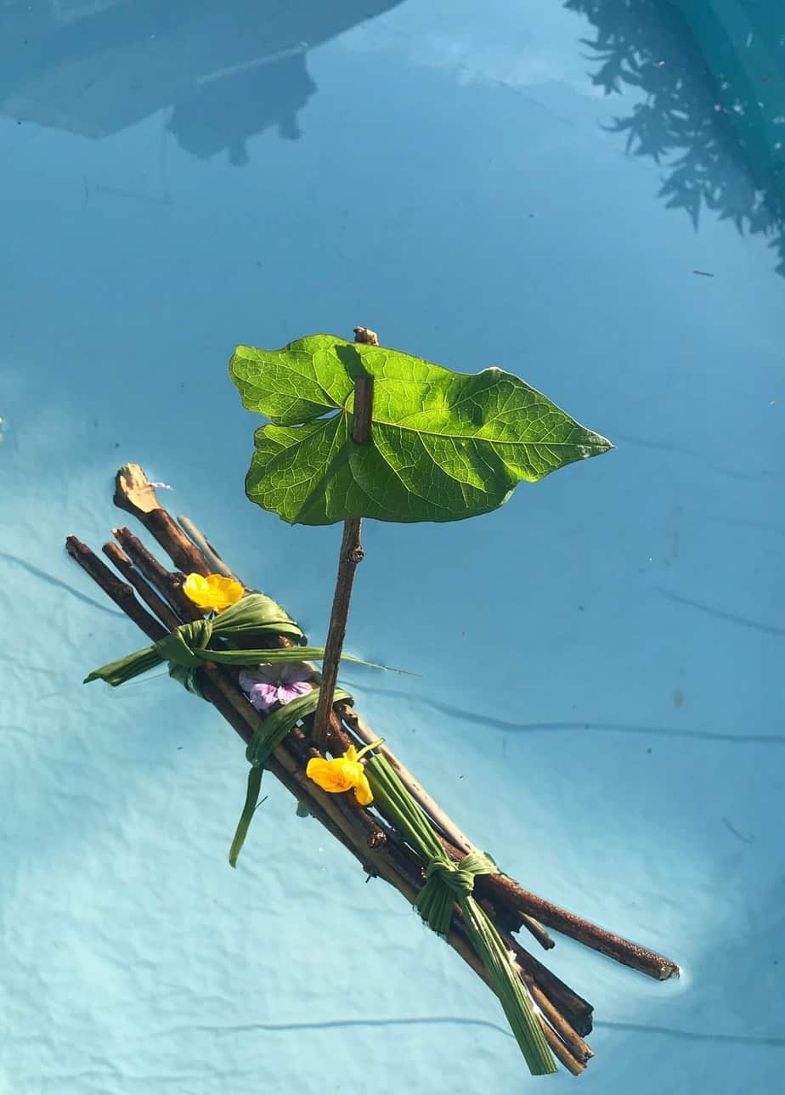

Activity: Use twigs at home to make a sailing boat. Run the bath and see whose boat can float!

What you will need: On your daily walk, collect lots of small twigs of different shapes and sizes. You may also want to collect other items like leaves for the sails and for joining (Also collect some small stones for tomorrow’s activities – enough for 2 stones per member of the family).

Extension activities: Have a boat race! Blow your boat – whose boat can travel the furthest?
Can you make more than one boat and compare them? Which one is better and why?
What properties make the boat float or sink?
What different materials can you use to join your boat together? Can you do this only using natural materials?

