Daily Family Together Activity

For each day of the week, Barningham CEVC Primary School will share one activity that families can do together. With children now spending so much time doing their learning on computers or tablets, these activities are designed to move away from the computer and bring the family together.
This is an optional activity and so does not need to be completed as part of the children’s home learning but if you would like to take part and share your activities with us, we would love to see them!

Tuesday 19th January
Dinosaur Footprint Cookies
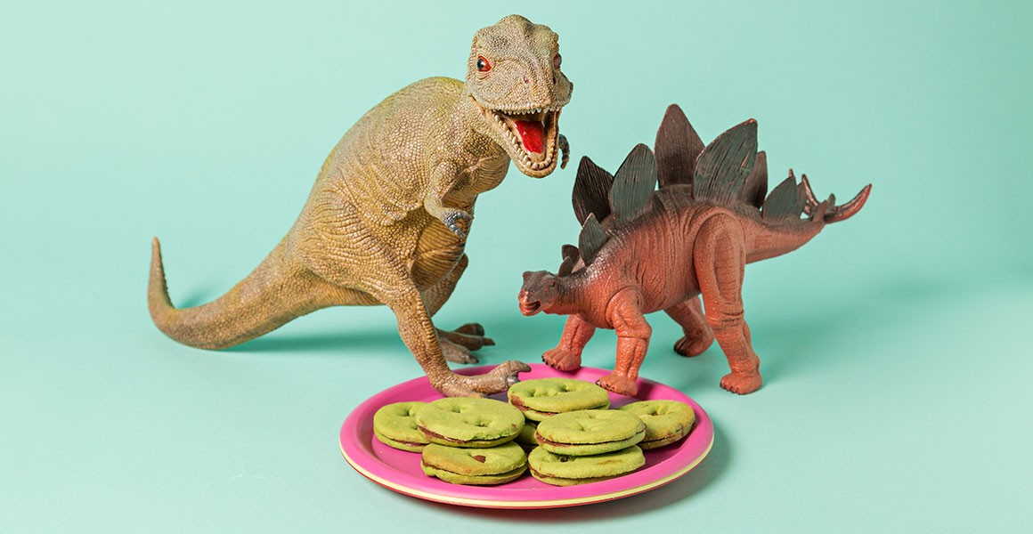
Activity: Use your favourite toy dinosaur (or any other toy creature) to create footprint cookies in the kitchen with your family. Please make sure an adult is supervising this task.

What you will need: plain flour, salt, caster sugar (or normal sugar if you haven’t got this at home), butter, 1 egg. Full recipe can be found on the link below with a simplified version on the next page.
https://www.nhm.ac.uk/discover/dinosaur-footprint-cookies-recipe.html

Extension activities: Can you cut the cookies into different shapes?
Can you use different toy animals to create different shaped cookies?
How many cookies can you make with this recipe? What if you wanted it to be bigger or smaller? How would you change the recipe?

Dinosaur Footprint Cookies Recipe

(Simple version)

Ingredients:
350g (9oz) plain flour
pinch of salt
175g (6oz) butter, room temperature
100g (4oz) caster sugar (or normal sugar If you don’t have this)
1 small egg, beaten

You will also need:
Knife to cut biscuit shapes (or a cookies cutter if you have one)
dinosaur model toy of suitable size (to make at least one footprint per biscuit), cleaned and dry

Method
1. Preheat the oven to 170°C/340°F/gas mark 3½. Cooking the biscuits at a moderate temperature avoids them turning brown.
2. Sift the flour and salt together into a bowl.
3. Rub the butter into the flour with your fingertips until the mixture looks like fine breadcrumbs (this step can also be done in a food processor).
4. Stir in the sugar.
5. Bind the mixture into a soft dough with the beaten egg. You don't want the dough to be too soft to roll, so just add half the egg mixture to begin with and see if more is required. If it looks too soft, sift in some more plain flour.
6. Wrap the dough and put it in the fridge for 30 minutes - cooled dough is easier to roll.
7. On a lightly floured board, roll out the dough to about 4mm thick.
8. Cut into rounds with a cookie cutter or shape using a knife. Reroll the pastry scraps and cut more rounds.
9. Take half of the rounds and cut dinosaur footprints into them: take the dinosaur and lightly dust its foot with flour, then squash the foot into the dough to make the footprint holes.
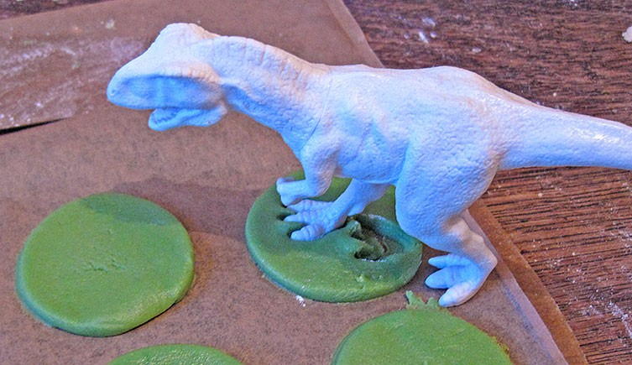
10. Place all the rounds on a baking tray lined with baking paper. (If your dough looks very soft at this stage, you can pop it into the fridge for 15 minutes to firm up.)
11. Bake at 170°C/340°F/gas mark 3½. Check after 15 minutes: the biscuits are done when the underside looks dry and might have begun to colour slightly, but will still be soft.
12. Cool on the baking tray for a few minutes so that the biscuits firm up, then slide them off and finish cooling on a wire rack.

