Daily Family Together Activity

For each day of the week, Barningham CEVC Primary School will share one activity that families can do together. With children now spending so much time doing their learning on computers or tablets, these activities are designed to move away from the computer and bring the family together.
This is an optional activity and so does not need to be completed as part of the children’s home learning but if you would like to take part and share your activities with us, we would love to see them!

Monday 18th January
Rainbow Treasure Hunt

Activity: Go on daily walk to your local park/outdoor area.
See if you can spot anything that matches all the colours of the rainbow.

What you will need: Warm clothes, walking shoes, carrier bag (printed rainbow is optional)

Extension activities: Can you collect any items and bring them home?
Who can collect the most different coloured items?
Who can collect the most of each colour? E.g. who has the most green items?
Can you draw the items you have found? And label them?
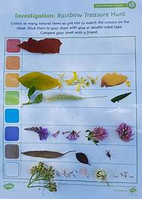
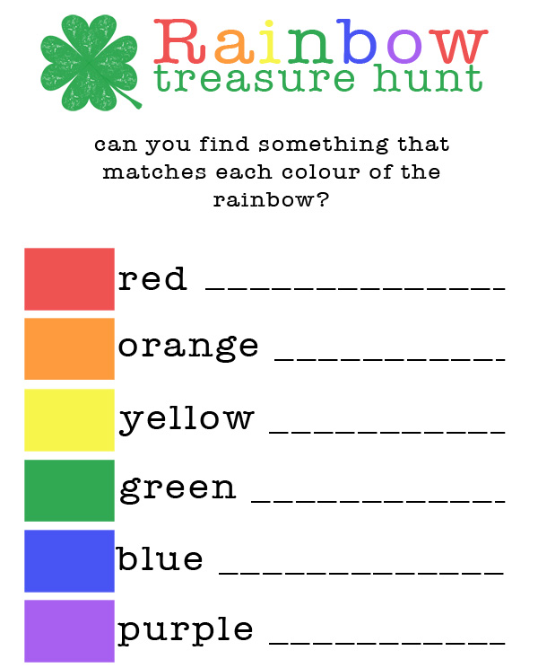

This is an example of how you might want to collect your items.

