Daily Family Together Activity

For each day of the week, Barningham CEVC Primary School will share one activity that families can do together. With children now spending so much time doing their learning on computers or tablets, these activities are designed to move away from the computer and bring the family together.
This is an optional activity and so does not need to be completed as part of the children’s home learning but if you would like to take part and share your activities with us, we would love to see them!

Friday 5th February
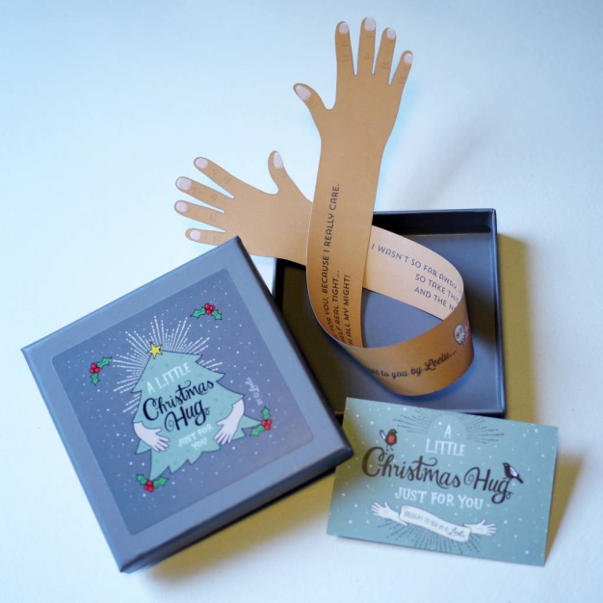
Send a Hug in the Post
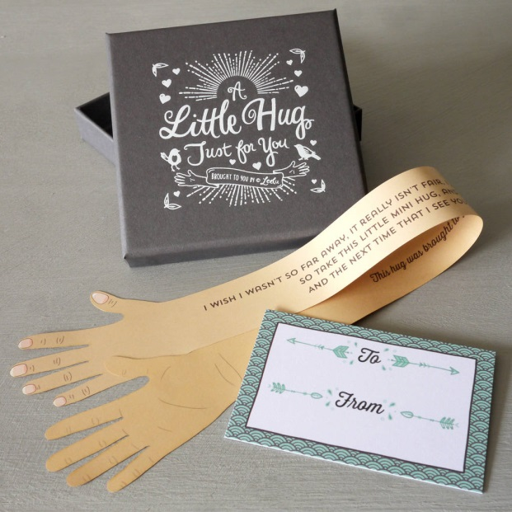
Activity: Get each person in your family to lie down over some paper on their back with their arms outstretched (if you only have A4 paper, connect these with sellotape or glue). Draw around their hands and arms to create a drawing like the pictures above. Cut out the hands and arms to create an outline of the person’s ‘hug’. Do this for all members of the household!

What you will need: paper, sellotape/glue, scissors, envelope and stamp (optional)

Extension activities: Write a message on the arms (see above) and send this in the post to someone who you can’t see, but want to send your ‘hug’ to.
If someone lives within walking distance of your house, on your daily walk with your adult, drop it off on their doorstep to show them how much you mean to them. Don’t forget to say who it is from!

