Daily Family Together Activity

For each day of the week, Barningham CEVC Primary School will share one activity that families can do together. With children now spending so much time doing their learning on computers or tablets, these activities are designed to move away from the computer and bring the family together.
This is an optional activity and so does not need to be completed as part of the children’s home learning but if you would like to take part and share your activities with us, we would love to see them!

Monday 1st February
Make an Origami Swan
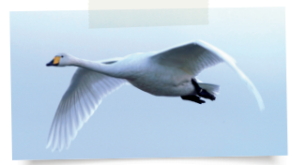
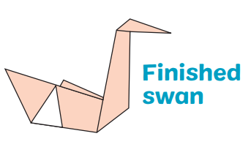
Activity: Use plain white paper to create an origami swan. Full instructions can be found on the next page.

What you will need: paper – ideally this should be cut to a square with equal sides before you begin, scissors

Extension activities: Can you research how to make other animals using origami?
Make the same swan using an A4 paper not cut to size. How does this impact your finished product?
Full instructions can be found here https://www.wwt.org.uk/uploads/documents/2020-04-22/wwt-origami-swan-sheet-1.pdf

