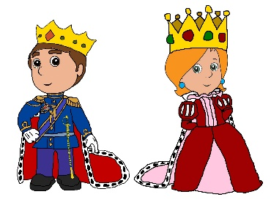

Maths

* Addition/subtraction
* Multiplication/division
* Time
* Position and direction

Literacy

* Traditional tales
* Poetry relating to Pentecost

Geography

* Urban and rural locations

Our topic this term is:

History

* Kings and queens

PSHCE

* Animal welfare

PE

* Rounders

French

* Family

Science

* Everyday materials and their uses

**Kings and queens**

Art/D&T

* Buildings

Music

* Exploring timbre, tempo and dynamics

Computing

* Word processing skills

RE

* Christianity – celebrations (Pentecost)