Physical Development with Spiderman:
This sticky spider web activity is perfect for indoor play, and can be done in any doorway or hallway using painters tape. Have some spider target practice by throwing balls of newspaper.

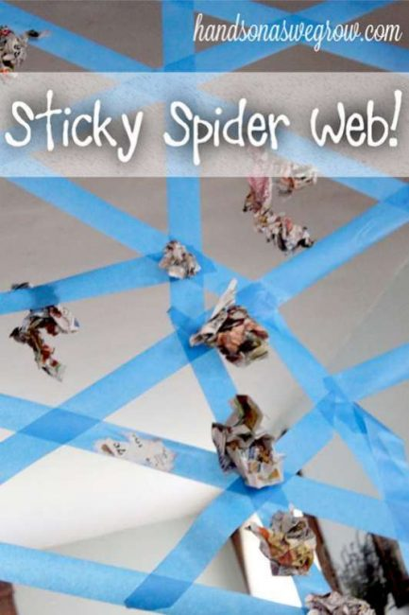
Maths:
Counting backwards to blast off in your superhero rockets.

Understanding of the World:
Science for superheroes – try the rainbow milk experiment. Please find the instructions on the back.
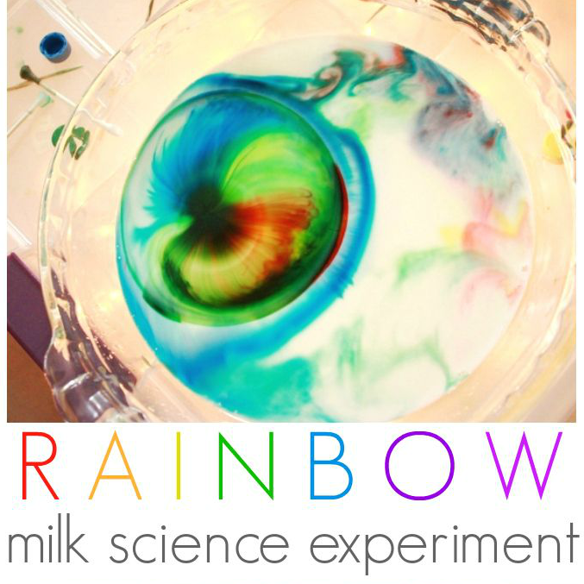
Heroes
Home School Learning
Sharing Date: 5th April
Please remember that these are suggestions, you can adapt these ideas and be as creative as you wish.

Art and Design:
Create your own super hero. What is their name? What special powers do they have?

Literacy:
Invisible writing. Write in white crayon and then paint over it with watered down paint so that it shows up.

Magic Rainbow Milk Science Experiment
Items Needed
- Milk (Must be either Whole or 2%)
- Food Colouring. The more colours the better
- Washing up liquid
- Shallow Dish or Bowl
Instructions
- Pour some milk into a shallow dish or bowl until the milk covers the bottom. Tip: Be sure to use either Whole or 2% Milk
- Add some drops of food colouring on the milk. You can use a variety of colours, just be sure to add 3-4 drops of each color.
- Add a drop of washing up liquid into the center of the milk or onto the end of a cotton bud and place tip of cotton bud into the milk.
- Watch in amazement as the colours dance across the surface of the milk

