PSHE:

* New beginnings

Art/DT: Drawing and Sketching

* Cooking a Roman Feast
* Design and make a Roman piece of jewellery from Clay
* Design and make a Roman shield

Music: Suffolk Music Service

* Reading simple music
* Rhythm and Beats
* Working together to create a piece of music

Science:

Scientists and Inventors

* Finding out about some of the key Scientists in history and what they discovered

English:

* Story Writing – Escape from Pompeii
* Roman mythical stories – Romulus and Remus
* Instructions - how to make Roman food
* Newspaper articles Vesuvius

Geography/History:

* A timeline of Roman History
* The Roman Empire and its impact on Britain
* Hadrian’s wall
* Invasion on Britain and the Romanisation of Britain
* The power of its army
* What have the Romans done for us?
* Where was the Roman Empire?

ICT:

* Internet safety
* Using the web

Maths:

* Number and place value
* Addition and subtraction
* Use Roman numerals
* Division and Multiplication
* Telling the Time

***The Roman Empire***

***Badger Class Autumn 2018***

[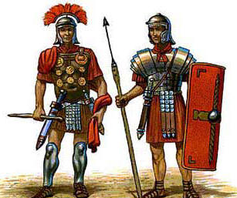](http://www.google.co.uk/url?sa=i&rct=j&q=&esrc=s&source=images&cd=&cad=rja&uact=8&ved=0ahUKEwitn_OA6vDNAhXpB8AKHdkEDbIQjRwIBw&url=http://www.relishrunningraces.com/roman-10km.php&psig=AFQjCNH7KAbDE8IOEvChkuwq_oXYx40HxA&ust=1468512622335068)

RE:

* Christianity – how does believing Jesus is their saviour inspire Christians to save and serve others?

PE:

* Swimming

French:

• La famille

* Alphabet
* Family
* Household items
* Prepositions