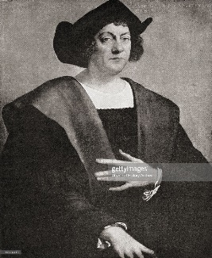

RE

* Islam – believing

Music

* Taking off – exploring pitch

PE

* Throwing and catching

Maths

* Time
* Measuring – length/height and mass
* Division
* Position and direction
* 3D shape

Geography

* Is it really round? – finding out about continents and oceans

Literacy

* Fantasy stories
* Information text
* Poetry

Our topic this term is:

Computing

* We are painters

History

* Great explorers – Ibn Battuta, Neil Armstrong, Christopher Columbus, Robert Falcon Scott

Art/D&T

* Food technology – dips and dippers

Science

* Plants

**Great explorers**

French

* My body