**Communication and Language:**

Why do Christians celebrate Christmas? What does your family do to celebrate Christmas?

**Understanding of the World**

Why do we eat mince pies at Christmas time? Are there any festive treats that your family likes to bake at Christmas?

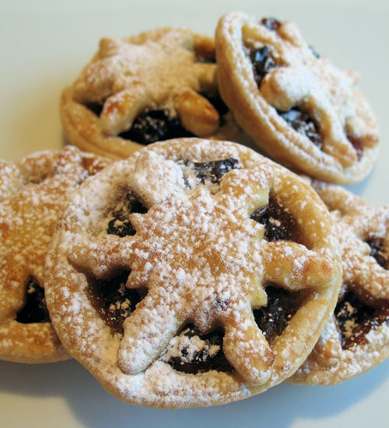

**Maths:**

Use the Christmas tree template to design your own tree. How many decorations are there on your tree? If you added one more how many would there be? Draw some presents under the tree. What shape are they? What could it be?



**Christmas Traditions**

Home School Learning

Please remember that these are suggestions, you can adapt these ideas and be as creative as you wish. Sharing date; Monday 18th December

**Art and Design:**

Create your own Christmas picture.

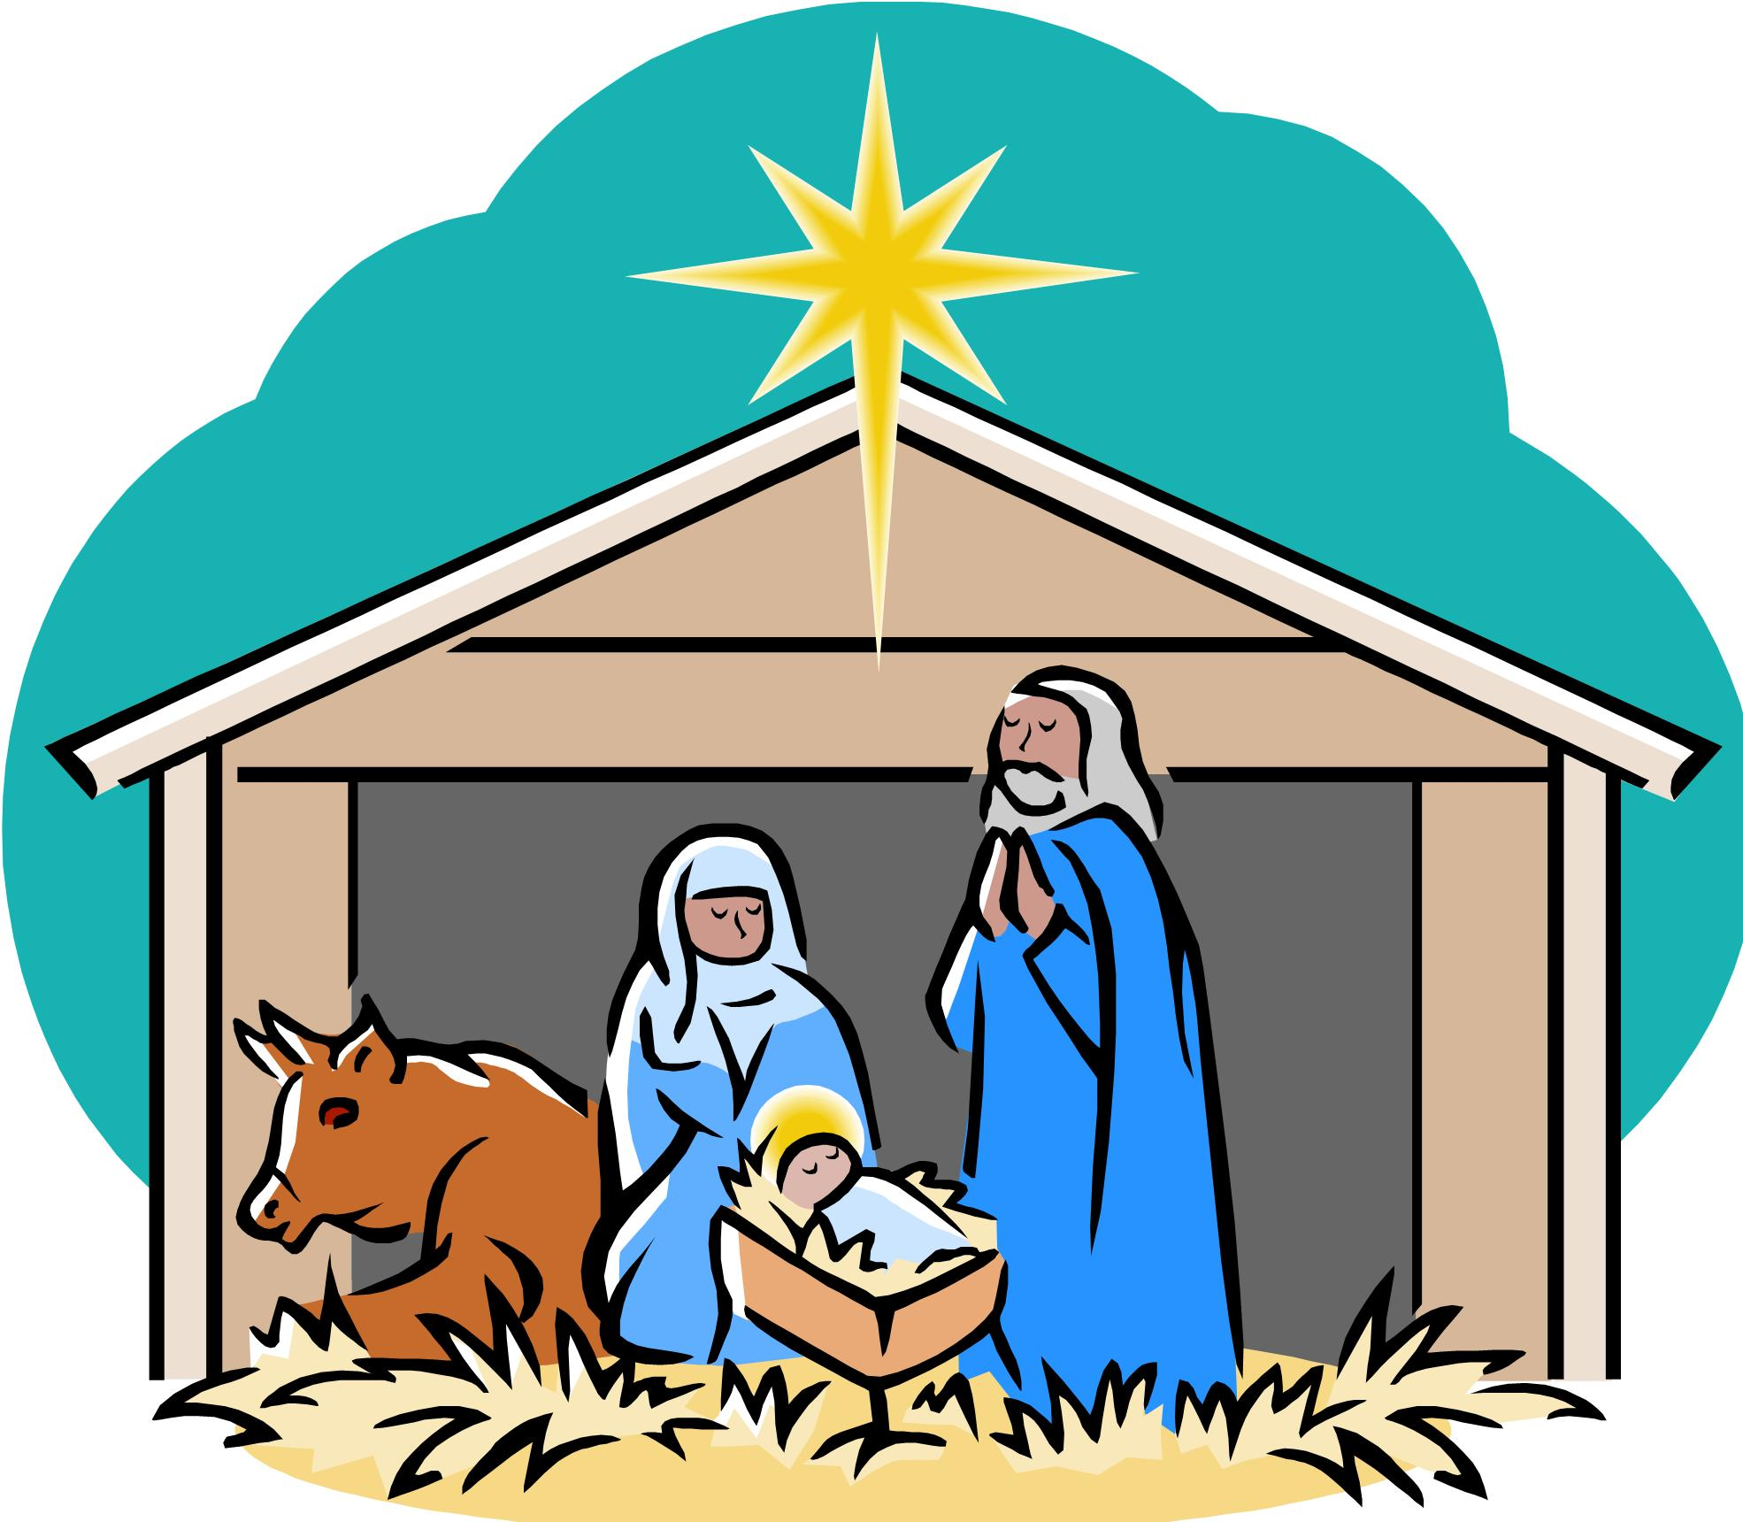

**Literacy:**

Can you write your own Christmas cards?