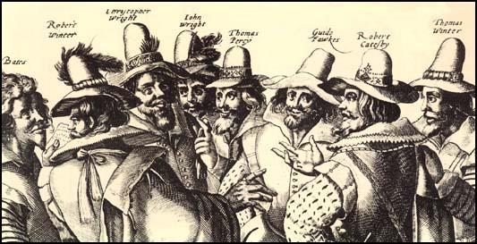

Literacy

* Traditional tale
* Instructions
* Poetry

Geography

* Polar bears or penguins

Maths

* Fractions
* Money
* Number and place value
* Statistics
* Measurement
* Time
* Addition

Our topic this term is:

Art/D&T

* Firework paintings
* Making a Guy Fawkes

Science

* Living things and their habitats

History

* The Gunpowder Plot

**Great and ghastly events**

PE

* Dance

French

* Celebrations

Music

* Feel the pulse – exploring pulse and rhythm

Computing

* We are TV chefs

RE

* Judaism – belonging