Science:

Light and Shadows

* Investigate how shadows are formed
* Which materials create the best shadow
* How light travels and how we see light

Plants

* Identify and describe functions of different parts of plants
* Explore the requirements of plants
* Investigate how water is transported

PE:

* Outdoor invasion games
* Gymnastics and Indian Dancing

Music:

* Using BBC 10 pieces
* Create atmospheric music to support a poem

Art/DT:

* Sketch Indian patterns
* Design and create templates to make repeating patterns on fabric
* Using Indian patterns to decorate an Elephant
* Create Rangoli patterns using spices

PSHE:

* New Beginnings
* Citizenship

***India***

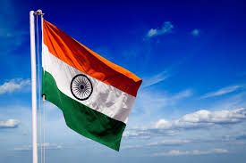

Maths:

* Number and Place Value
* Addition and Subtraction
* Multiplication and Division
* Measure – Time
* Fractions and Decimals

ICT:

* Using word to produce a poster about life in India

French:

* Salut Gustave!

RE:

* Sikhism – Equality

Geography:

* Map work – placing India on a world map and mapping India
* What is it like to live in Delhi?
* Compare living in Delhi to living in Bury st Edmunds
* Compare transport in India to the UK
* Research homes in India – compare to your home
* Compare climate in India to the UK and graph.

Literacy:

Stories from other cultures;

* The Tiger Child
* The Monkey and the Crocodile

Poetry;

* Tiger, Tiger

Information Text;

* Writing a report – tigers as an endangered species

Instructions;

* Writing based on Indian cooking