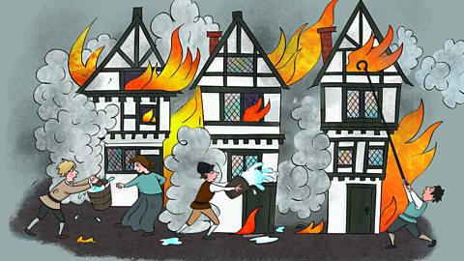

Literacy

* Stories in familiar settings
* Stories from another culture
* Diary writing
* Poetry

Geography

* Up, up and away – learning about the United Kingdom

Maths

* Number and place value
* Addition and subtraction
* Multiplication and division
* Fractions
* Properties of shape

Our topic this term is:

Art/D&T

* Fire paintings
* Making a 3D Tudor house

Science

* Living things and their habitats

History

* The Great Fire of London

**Great and ghastly events**

PE

* Football
* Dance

French

* Introductions

Music

* Exploring sounds

Computing

* We are treasure hunters

RE

* Judaism – believing