Music:

* play and perform in solo and ensemble contexts with increasing accuracy, fluency, control and expression
* improvise and compose music using the inter-related dimensions of music
* listen with attention to detail and recall sounds with increasing aural memory

RE:

* Christianity - Old Testament stories
* Hinduism – Beliefs and religious teachings

History:

* Victorians - a study of an aspect or theme in British history that extends pupils’ chronological knowledge beyond 1066
* develop a chronologically secure knowledge and understanding of British, local and world history, establishing clear narratives within and across the periods they study

PE:

* Gymnastics - develop flexibility, strength, technique, control and balance
* Dance - perform dances using a range of movement patterns

ICT:

* Productivity; We are market researchers
* understand computer networks including the internet; how they can provide multiple services, such as the world wide web; and the opportunities they offer for communication and collaboration
* use search technologies effectively, appreciate how results are selected and ranked, and be discerning in evaluating digital content

***The Victorians***

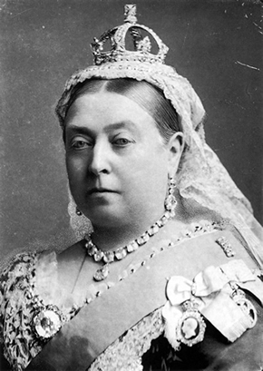

Geography:

Victorian empires around the World

* use maps, atlases, globes and digital/computer mapping to locate countries and describe features studied
* use the eight points of a compass, four and six-figure grid references, symbols and key (including the use of Ordnance Survey maps) to build their knowledge of the United Kingdom and the wider world

Art/DT:

* Printmaking - to improve their mastery of art and design techniques, ad develop understanding of great artists, architects and designers in history.
* Cooking - understand and apply the principles of a healthy and varied diet
* Cooking - prepare and cook a variety of predominantly savoury dishes using a range of cooking techniques
* Moving toys – design, make, evaluate and develop technical knowledge

Science:

* Life cycles ~ comparing these
* Changes as humans develop to old age
* identify and name the main parts of the human circulatory system, and describe the functions of the heart, blood vessels and blood
* recognise the impact of diet, exercise, drugs and lifestyle on the way their bodies function
* describe the ways in which nutrients and water are transported within animals, including humans.
* Animals, humans and health

French:

Rigolo - develop understanding of oral and written language

PSHE:

~ Say No To Bullying

~ Relationships and citizenships

Maths:

* Read, write, order and compare numbers
* Rounding numbers
* Formal written methods of addition and subtraction
* Problem solving
* Formal written methods of multiplication and division
* Introduction to algebra
* Calculating perimeter, area and volume

Literacy:

* Read and discuss a wide range of texts
* Recommend books to others
* Making comparisons within and between texts
* Infer character’s feelings, thoughts and motives from actions
* Identify how authors use language
* Using dictionaries to check spelling and meaning of new words
* Plan, draft and evaluate writing, considering purpose and intended audience
* Handwriting and presentation
* Spelling
* Developing punctuation used in writing
* Formal writing
* Relative clauses