**Owl Class Homework**

**Owl Class Homework**

Memory Bottle

Memory Bottle

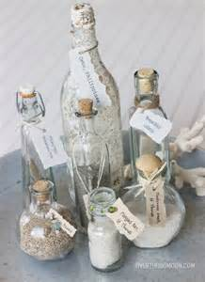



**To encourage the children to talk about their learning and what they are doing at school, we would like the children to complete a task at home.**

**We would like the children to make a memory bottle of their time at Barningham CEVC Primary School. They could include pictures, writing and photos. Be creative!**

**To encourage the children to talk about their learning and what they are doing at school, we would like the children to complete a task at home.**

**We would like the children to make a memory bottle of their time at Barningham CEVC Primary School. They could include pictures, writing and photos. Be creative!**