**Communication and Language:**

Use minibeast puppets to retell and create stories.

**Understanding of the World**

Help the bee population! Find out which types of plants bees like and plant some flowers to attract bees to your garden.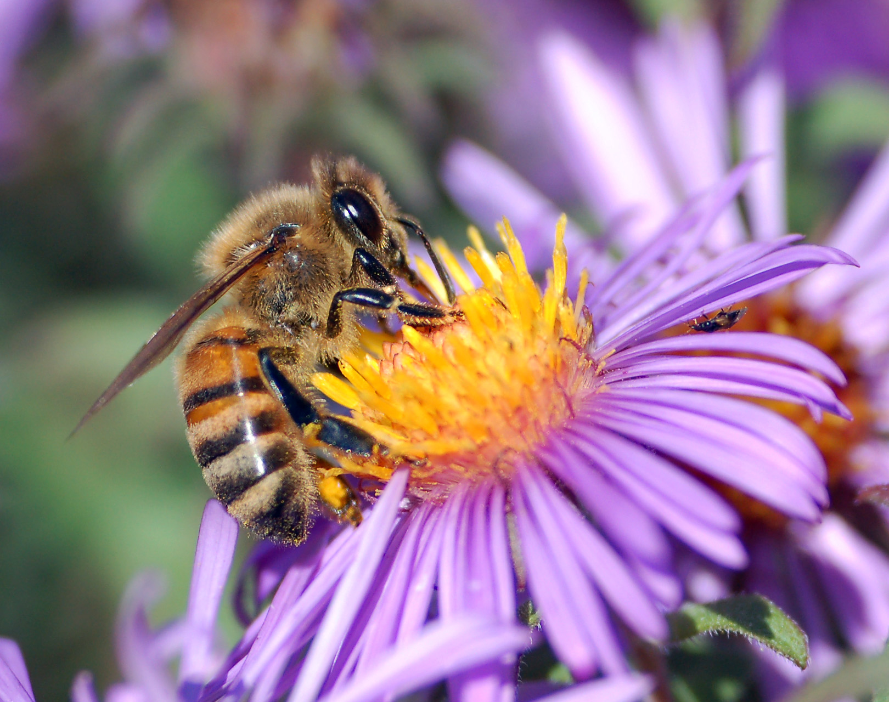

**Maths:**

Carry out a minibeast survey using tally/mark making charts.



**Mini Beasts**

Home School Learning

Sharing Date: Monday 17th July

Please remember that these are suggestions, you can adapt these ideas and be as creative as you wish.

**Art and Design:**

Make minibeast puppets.

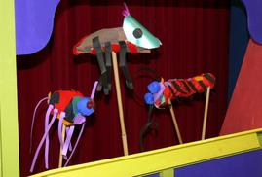

**Literacy:**

Share a story about a minibeast. Can you write book review for it?