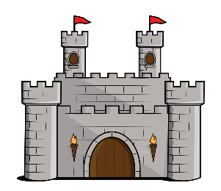

Maths

* Number and place value
* Multiplication and division
* Addition and subtraction
* Fractions
* Measurement
* Position and direction
* Statistics

Literacy

* Traditional tales
* Letters
* Poetry relating to Pentecost

Geography

* Urban and rural locations

Our topic this term is:

History

* UK heritage – focus on castles

PSHCE

* Healthy bodies

PE

* Healthy bodies
* Running
* Throwing and catching

French

* How to say different buildings
* How to say colours

Science

* Everyday materials and their uses
* Seasonal changes – summer

**Castles**

Art/D&T

* Design and make a cushion for a throne

Music

* Exploring timbre, tempo and dynamics

Computing

* We are researchers

RE

* Christianity – celebrations (Pentecost)