

Maths

* Number and place value
* Addition and subtraction
* Multiplication and division
* Measurement

Literacy

* Stories from other cultures
* Recounts
* Poetry

Geography

* Where shall we go on Safari? – finding out where Kenya is in the world

Our topic this term is:

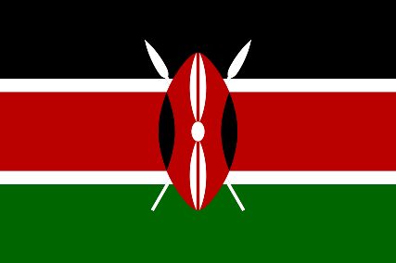

History

* Woman who changed history – looking at the impact women had on history
* Mary Jones, Florence Nightingale, Grace Darling

PSHCE

* Healthy minds

PE

* Kenyan dance
* Ball skills

French

* How to say different countries in French
* How to say where I live

Science

* Animals
* Seasonal changes – winter into spring

**Around the World**

Art/D&T

* Kenyan art
* Tingatinga paintings
* Kenyan collage

Music

* Exploring instruments and symbols

Computing

* We are photographers

RE

* Christianity – prayer and worship