**Communication and Language:**

Learn a song about dinosaurs to share with the class.

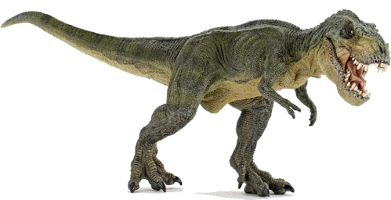

**Understanding of the World:**

Make some play dough, then you can push shells and model dinosaurs into it to look like fossils.

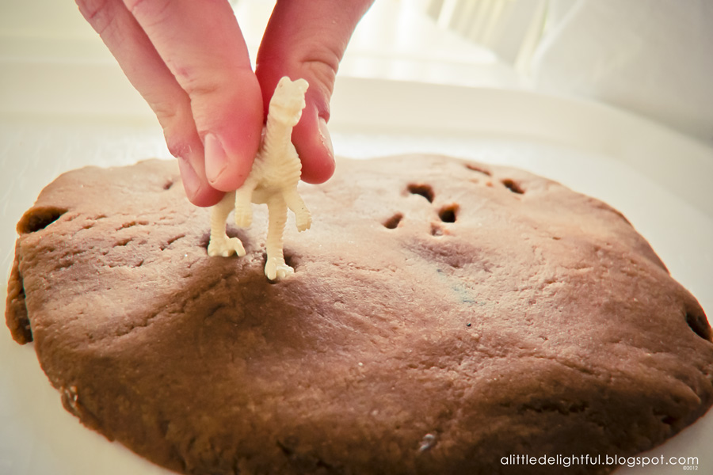

**Maths:**

Use your dinosaur number line to count on and back to solve the addition and subtraction sums on the sheet attached.

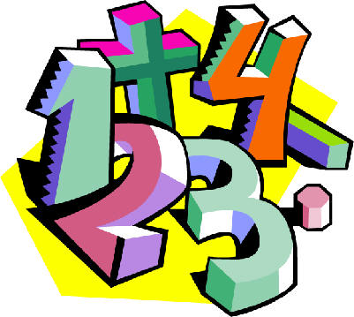

**Dinosaurs**

Home School Learning

Sharing Date: 30th March

Please remember that these are suggestions, you can adapt these ideas and be as creative as you wish.

**Art and Design:**

Can you make a junk model dinosaur?

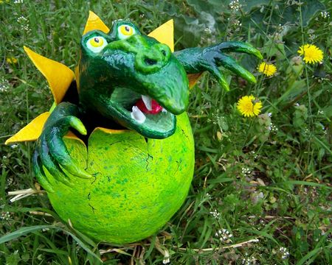

**Literacy:**

Can you make a fact file about a dinosaur. How big was it? What did it eat? What did it look like? Where did it live?