PE:

* Gymnastics
* Games

RE:

* Inspirational People, Hinduism and Sikhism

PSHE:

* Citizenship and Sustainable

***The Amazon Rainforest***

[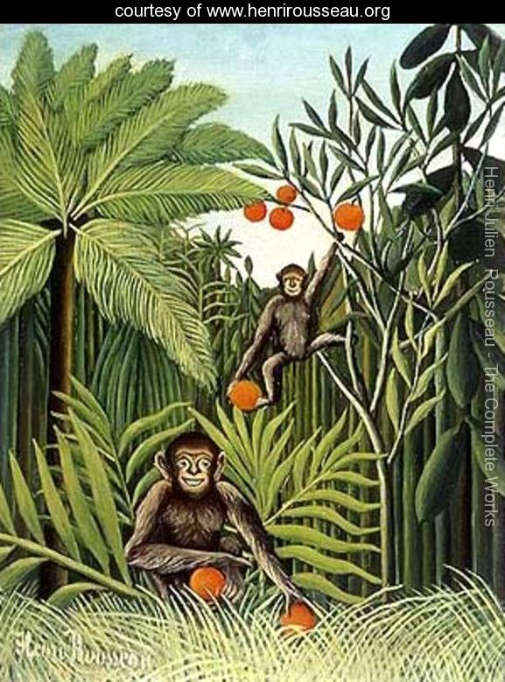](http://www.google.co.uk/url?sa=i&rct=j&q=&esrc=s&source=images&cd=&cad=rja&uact=8&ved=0ahUKEwjvgNOZw6HRAhWH0xQKHTS9BYsQjRwIBw&url=http://www.henrirousseau.org/&bvm=bv.142059868,d.ZGg&psig=AFQjCNG9dpeWxfltrw0-kn2AlGzjdxNsKg&ust=1483379970460999)

Science:

Living things and their habitats

* Classification
* Identify and name living things
* Identify the 7 characteristics of living things
* Observational and large scale drawings of insects

Plants

* What do plants need to grow?
* Grow our own plants, changing the conditions.
* Parts of a flowering plant
* Pollination

Literacy:

Work based on the book The Kapok Tree

* Writing a story based on a known book – a warning tale
* Discussion – the effects of deforestation and the impact on the animals who live there
* Persuasion – letter to persuade the reader why they shouldn’t cut down the trees in the rainforest

Art/DT:

* Making a model of the layers of the rainforest
* Find out about Henri Rousseau and recreate Amazon Rainforest pictures in his style

Maths:

* Division
* Fractions and Decimals
* Coordinates
* Length and mass
* Volume and capacity

Geography:

* Continents, equator, tropic of cancer and Capricorn, longitude, latitude, time zones
* Where is the Amazon Rainforest?
* Physical geography – climate zones, vegetation, rivers, layers, wildlife

Music:

* Sessions from the Suffolk County County music service

ICT:

* Presenting and filming ourselves
* Programming and learning how to use Scratch

French:

* En Classe
  + Learning about school
* Mon Corps
  + Finding out the parts of our body