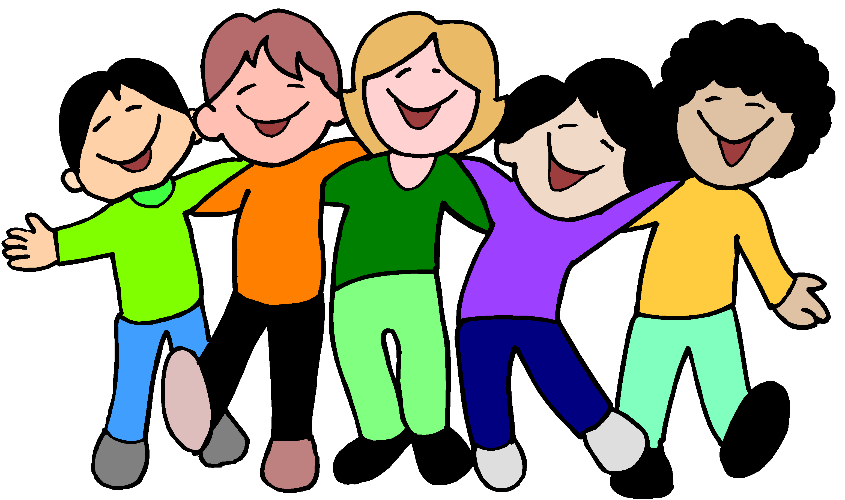

Geography

* What is there around me? – looking at village, maps

Literacy

* Fantasy
* Labels, lists, signs and poster
* Poetry

Maths

* Number and place value
* Addition
* Subtraction
* Multiplication
* Division
* Measurement
* Statistics

History

* Telephones

Our topic this term is:

Science

* Healthy lifestyles
* Seasonal changes – autumn into winter

Art/D&T

* Self portraits
* Vehicles to help ourselves e.g. cars, buses, ambulances

PE

* Dance
* Tag rugby

French

* Introductions
* Alphabet
* About self

Music

* Exploring pulse and rhythm

PSHCE

* Relationships and citizenship
* New beginnings

Computing

* We are astronauts
* We are game testers

RE

* Christianity
* Believing

**Ourselves**