Geography/History:

* Hadrian’s wall
* What have the Romans done for us?
* Boudicca

French:

• Bon anniversaire

Literacy:

* Roman mythical stories
* Poetry
* Instructions

Maths:

* Length and mass
* Volume and capacity
* Multiplication and Division

Music:

* Lessons with Suffolk County Council music service

***The Roman Empire cont…***

[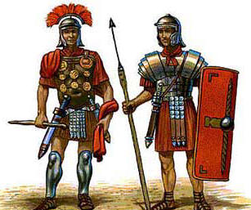](http://www.google.co.uk/url?sa=i&rct=j&q=&esrc=s&source=images&cd=&cad=rja&uact=8&ved=0ahUKEwitn_OA6vDNAhXpB8AKHdkEDbIQjRwIBw&url=http://www.relishrunningraces.com/roman-10km.php&psig=AFQjCNH7KAbDE8IOEvChkuwq_oXYx40HxA&ust=1468512622335068)

PSHE:

* New beginnings

ICT:

* Internet safety
* Using the web
* E-mail

RE:

* Islam – prophethood

Art/DT:

* Design and make a Roman piece of jewellery from Clay
* Stockings to hang on the fireplace

PE:

* Gymnastics
* Dance

Science:

Electricity

* Construct simple circuits
* Recognise that a switch opens and closes a circuit