Literacy:

* Non-chronological reports
* Persuasive writing
* Diary entries
* Newspaper reports
* Narrative
* Poetry

Science:

Living things

* Classification
* habitats

Maths:

* Calculate the passing of time
* Fraction
* Length and mass
* Volume and capacity

Geography/History:

* Battle of Britain
* Effect on WWII
* What it was like for children during the war.

Music:

* Exploring instruments
* Composition

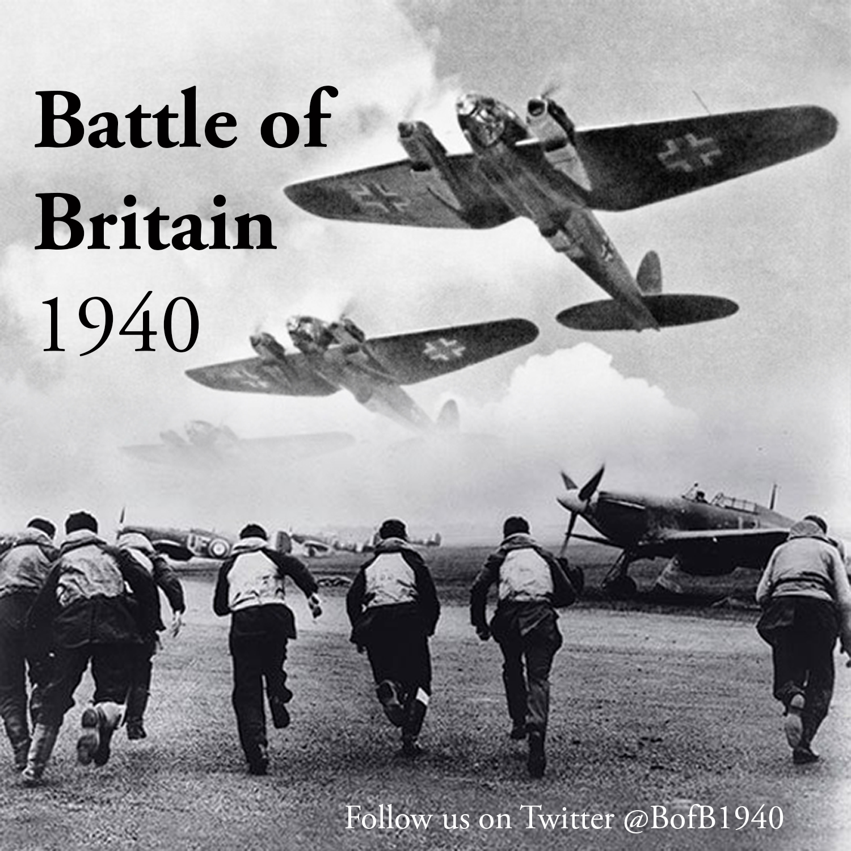

PSHE:

* Citizenship

ICT:

* Word documents
* Spreadsheets

RE:

* Christianity
* Islam

Art/DT:

* Puppet theatres

PE:

* Gymnastics
* Dance

French:

• Self-description

* Holidays
* Home