[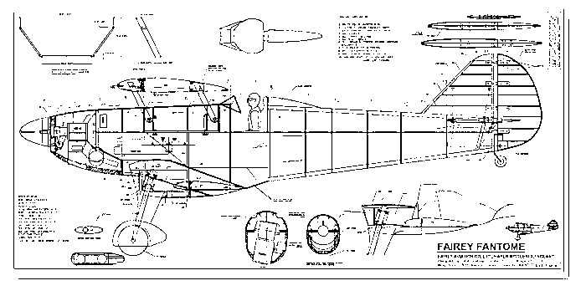](http://www.google.co.uk/url?sa=i&rct=j&q=&esrc=s&source=images&cd=&cad=rja&uact=8&ved=0ahUKEwi0tJu48pbNAhVLOMAKHdqXBp0QjRwIBw&url=http://www.rc-airplanes-simplified.com/large-scale-model-aircraft.html&psig=AFQjCNFn72UVi7RUqIi6Yx2Gn6HnzpkCYQ&ust=1465422497367722)

***I’d like you to imagine you are Sherman and you are using your scientific knowledge to design a machine, this does not have to be a flying machine! Think about what you have been learning in Science, magnets, forces, friction, resistance and magnetic poles. Use your imagination, your machine might be to boil an egg, do the washing, drying and ironing, complete your homework, but it must use the scientific concepts we have been learning. How you choose to present your design is your choice.***

***Where can your imagination and creativity take you?***

***Homework for the second half of the Summer Term***