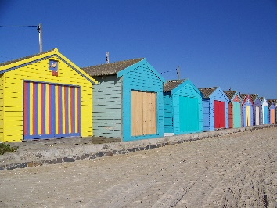

Geography and History

* Coasts
* We will be locating different sea sides across the UK
* Sea sides in the past- What were they like? What buildings did they have?

Literacy

* Writing non-fiction texts about the seaside.
* Writing extended stories based on an ‘Amazing Pebble’
* Stories in fantasy worlds

Maths

* Data handling
* Addition and subtraction
* Multiplication and division
* Time intervals

PE

* Athletics with Will
* Games
* Sports day practice

PSHCE

* Feelings
* How to deal with different emotions.

Our topic this half term is:

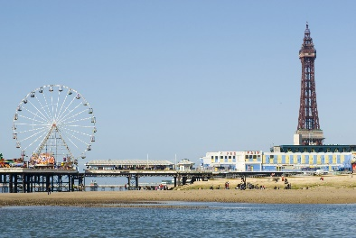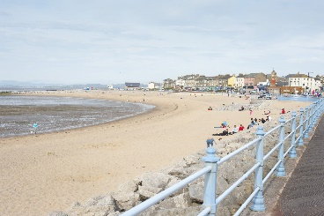

Science

* Similarities and differences between living things.
* Classifying and grouping living things.

Art

* Using natural objects such as shells, pebbles, rocks, and sand to inspire our own ideas.
* Using different textures to create art.

D&T

* Planning, designing and making fruity ice lollies.
* Making a rain maker to sound like the sea!

Music

* Creating music using sea side sounds.

RE

* Christianity
* Stories and books and their value in religion

French

* Greetings and responses
* Learning from French stories
* Numbers to 10
* Days of the week

**Seasides in the UK!**

Computing

* *We are researchers*
* Researching UK coast lines and what they are like.
* Designing, creating and presenting a sea side Powerpoint.