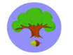
Squirrel class are at the beach
You could have:
Sun cream
Towels
Buckets & spades
Sun glasses
Reading books
Ice cream cone themed items
Lollypop moulds
Shells

Please can you add to our
Class Raffle Box?

