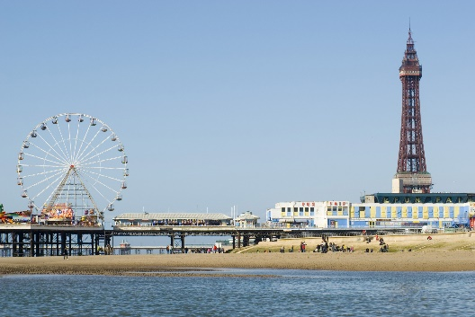

**Seasides in the UK**

**Project homework**

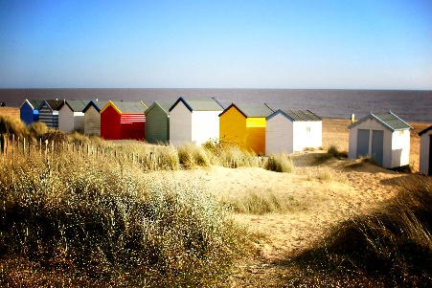

**Design and technology and Art**

* Plan, design and make your very own beach hut! Think about what it will look like, the decorations and how you will make it special to you!
* Create a seaside scene using different objects found at the seaside. Think about the different materials you can use to make a range of textures for effect!
* Create a Pirate’s treasure map.

**Geography and History:**

* Make a poster about your favourite seaside destination in the UK!
* Visit the sea side and take some photographs of your day. Write a diary about your day at the sea side and what you did whilst you were there!
* Find out the history of a seaside that you are familiar with. What buildings are there? What were the buildings used for? Can you find any photographs or pictures of seasides in the past?
* Research the journey you take to get to your favourite seaside!

