[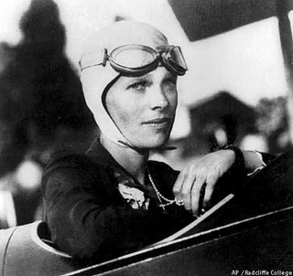](http://www.google.co.uk/url?sa=i&rct=j&q=&esrc=s&source=images&cd=&cad=rja&uact=8&ved=0ahUKEwjV4cX14dLLAhXJwxQKHaiPCWIQjRwIBw&url=http://www.holidaysmart.com/1ameliaearhart.htm&psig=AFQjCNFfE5Tf-ek3l7xDabDaWuPIeqv1cA&ust=1458683557843182)

***Air travel***



Geography/History:

* The history of air travel.
* Who invented the plane?
* How has air travel changed over the last 100 years?
* Who are the significant figures related to air travel?
* What is the history of space travel and the future for space travel?

RE: Symbols and religious expression

* Is the cross a symbol of love, sacrifice or commitment for Christians?

PSHE: Good to be me

* Feelings; surprised, relaxed
* Discuss the things I am good at
* Hiding my feelings
* Being assertive
* Think before I act

Maths:

* Measure – length, mass, volume
* Measure – money
* Division
* Addition
* Subtraction
* Read the time, analogue and digital and 24 hour

Science: Forces and Magnets

* Compare how things move on different surfaces
* Notice that some forces need contact between two objects, but magnetic forces can act at a distance
* Observe how magnets repel and attract
* Identify magnetic materials and group everyday objects
  + Describe how magnets have two poles

ICT: We are presenters

* Writing a script and making a film

Music:

* BBC 10 pieces – Holst Planets

Art/DT: Peter Thorpe – Abstract artists – Space

* To paint an abstract painting in the style of a famous artist

PE:

* Outdoor – Cricket
* Indoor – Swimming

Literacy: Amy Johnson, The Wright Brothers and Amelia Earhart

* Persuasive letter writing
* recounts
* Historical stories
* Poetry

French: The Hungry Caterpillar

* Days of the week
* Food
* Using a well-known story to write our own version in French