**Design and technology and Literacy**

* Prepare a healthy dish and write a recipe for others to use!
* Make a fruity smoothie and record how you prepared and made it.
* Write an evaluation for your recipe, what did it taste like? How could you improve your dish?
* Write an adventure story about travelling the world.

**Geography:**

* Choose five different foods that you eat and work out how many miles they have travelled to reach your plate.
* Create a poster about a country and the types of food produced there.
* Collect food packaging to find out where your food comes from and present your findings.

C:\Program Files\Microsoft Office\MEDIA\CAGCAT10\j0233312.wmf

C:\Program Files\Microsoft Office\MEDIA\CAGCAT10\j0149887.wmf

**Religious education:**

* Research Harvest, finding out why it is an important Christian festival.

From Field to Fork

Home School Learning

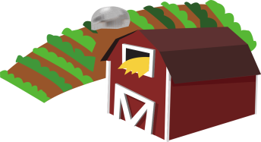

**Art:**

* Use different techniques to produce a drawing/painting of a local landscape. Perhaps use a photograph as a starting point!

**Science:**

* Keep a food diary for a week recording yours meals, snacks and drinks.
* Grow your own fruits or vegetables – I wonder if they’ll be tastier than the ones from other countries?
* Grow your own plant and record information about it growing (use photographs, measure, etc.). How will you keep it healthy?

**Maths:**

* Carry out an investigation and present your findings in a table or chart.
* *An example would be a tally chart to show the most popular countries for growing fruit and vegetables.*
* Create your own set of maths word problems involving the weight of food. E.g. Sam needed 500g of apples. Each bad contained 200g of apples. How many bags would he need? How many grams of apples would be left over?