**Design Technology:**

Design and make an Easter egg box. Be creative when designing your box! Think of different shapes you can use. Is your box going to have a logo? Can you include something nobody else has thought of?

**Easter **

Home School Learning

**Art:**

Make an Easter hat. Be as creative as you like!

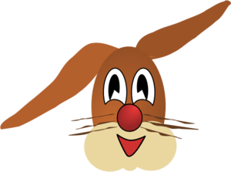

**History:**

Research the history of the Easter egg. Why do we have Easter eggs?



**Literacy:**

Create a story map of the Easter story.

