[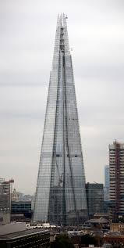](https://www.google.co.uk/imgres?imgurl=http://www.serenityeye.com/wp-content/uploads/2013/05/2012-040-004.jpg&imgrefurl=http://www.serenityeye.com/image-time-the-shard/&h=2000&w=1006&tbnid=7jMid59vHohMoM:&docid=91bs8-47ItHWTM&ei=H-mIVsXgJoeQaMqtnFg&tbm=isch&ved=0ahUKEwiF7Lu5qY3KAhUHCBoKHcoWBwsQMwhTKBcwFw)[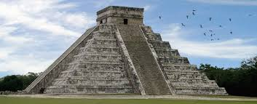](https://www.google.co.uk/imgres?imgurl=http://weare6thgraders.weebly.com/uploads/1/3/6/4/13642068/476826_orig.jpg&imgrefurl=http://weare6thgraders.weebly.com/mayan-culture.html&h=264&w=650&tbnid=HyCk8-URkpHNUM:&docid=ahuTrVibtRAVPM&ei=4uiIVuOfF4XxaOjDorgC&tbm=isch&ved=0ahUKEwjjmKGcqY3KAhWFOBoKHeihCCcQMwhEKBAwEA)[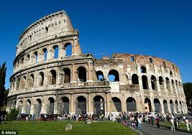](https://www.google.co.uk/imgres?imgurl=http://i.dailymail.co.uk/i/pix/2014/12/18/20B5C53500000578-0-image-m-2_1418942912605.jpg&imgrefurl=http://www.dailymail.co.uk/news/article-2879870/They-came-saw-concreted-Scientists-uncover-secret-ingredient-means-Roman-buildings-standing-1960s-towerblocks-crumbling.html&h=447&w=634&tbnid=R6sHqD680eCuXM:&docid=DXN0F9LEWDzynM&ei=UeiIVsaPNoGTasvgmpgL&tbm=isch&ved=0ahUKEwiG_K3XqI3KAhWBiRoKHUuwBrMQMwhBKA0wDQ)

***Buildings***

PSHE:

* Getting on and Falling Out

ICT:

* Collecting and analysing data
  + We are opinion pollsters

Music:

* BBC 10 pieces

Geography/History:

* Study the nature of buildings in some ancient civilisations.
* Study changes in buildings throughout British History.
* The Locality of the buildings we are studing.

RE:

* How do Christians show that reconciliation with God and other people is important?

Art/DT:

* Draw and paint images of buildings
* Sculpt in the style of some ancient artefacts

PE:

* Outdoor – Hockey
* Indoor – Invasion games

Maths:

* Calculate the passing of time
* Use Roman numerals
* Statistics
* Read calendars
* Count in negative numbers
* Money
* Properties of shape
* Fractions, decimals and percentages

Literacy:

* Write mythical stories and legends
* Write non chronological reports
* Write stories of adventure based on events in history

Science:

* States of matter
  + Solids, liquids and gasses
  + Changing state
  + Evaporation and condensation

French:

• Parts of the body and character descriptions

• Days of the week

• Animals

• Easter songs

•Revision:- classroom instructions and objects, numbers to 20, colours, asking and saying your name.