**Communication and Language:**

Share a story about a polar animal. Talk about the pictures together. Who is the main character? Where is the story set? What do you think will happen? What was your favourite part of the story?

We have lots of books if you would like t borrow a story.

Learn a song about a polar animal to share with the class.

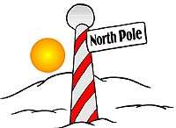

**Understanding of the World:**

Research a polar animal of your choice. Where do they live? What do they eat? What do they look like? What are its babies called?

**Polar Regions**

Home School Learning

**Maths:**

Find out the size of different animals that live in the Polar Regions? Which is the largest animal which is the smallest animal? Measure your height to compare.

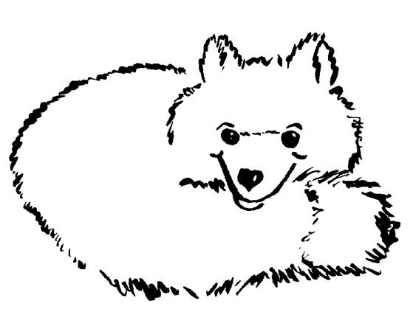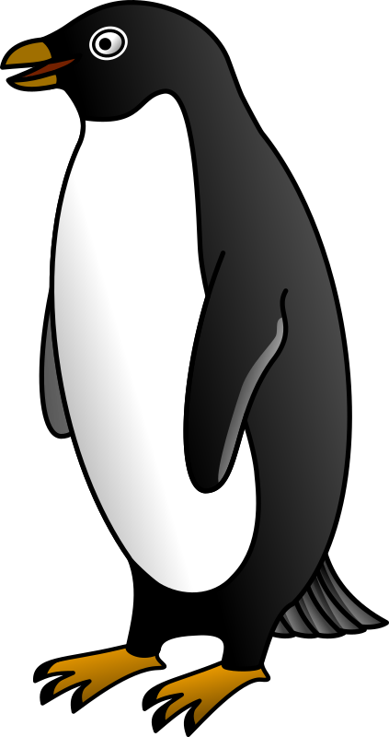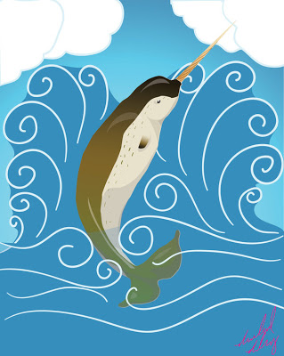

**Literacy:**

Can you think of 10 interesting and exciting words to describe winter weather?



**Art and Design:**

Can you make an igloo? You could use: paper mache, duplo, Lego, wooden blocks, ice cubes, sugar cubes or any thing you like really. Take a picture of your igloo to share with the class.