16th September 2015

Dear Parent/Carer

Kingswood Residential – Information Evening

This year’s trip to West Runton’s Kingswood Centre on Wednesday 7th to Friday 9th October is fast approaching.

We would like to invite you and your child to attend a short information evening on Monday 28th September starting at 6.00pm, where details of travel arrangements, activities available and kit list will be given.

We look forward to seeing you.

Yours sincerely

Mrs F Parr
Headteacher

To learn, aspire, believe and hope.

Barningham CEVC Primary School is committed to safeguarding and promoting the welfare of all children. The Designated Safeguarding Lead is Mrs Parr, the Alternate Designated Person is Mrs Pipe and the Governor with responsibility for Safeguarding is Mrs Hall.

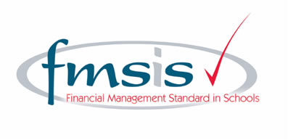
SUFFOLK COUNTY COUNCIL

