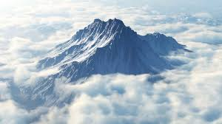

French:

* All about food!

ICT:

Excel, making bar charts and recording information

Art/DT:

* Make pots from clay based on Greek pottery
* Find out about Greek art and designs and their significance, draw these and paint them on our pots
* Collage

Maths:

Measure

* Measure and compare length
* Measure and compare mass
* Measure and compare volume
* Perimeter of 2d shapes
* Area of 2d shapes
* Confidently understand and use money and work out total cost and change
* Solving Word Problems using measure

Interpreting Data – answering questions using graphs and charts

RE:

Christianity: Why is the cross more than a symbol of sacrifice?

***Ancient Greece***

***The Olympic Games***

Science:

Sound

* Identify how sound is made
* Investigate vibrations from sound travelling through the ear
* Investigate materials for sound proofing

History:

* To find out about the significance of Mount Olympus, and Sparta
* To look at Greek architecture
* To find out about Greek Gods and their significance

PE:

* Dancing
* Creating our own Olympic games events

Music:

* Creating our own rhythms and using our body as a musical instrument

Literacy:

* Persuasive Writing – writing adverts to persuade people to take part in or come to watch the Olympic Games.
* Persuasive Writing – letters to persuade the Spartans to take part in the Olympic games.
* Newspaper reports – report on events at the Olympic Games