[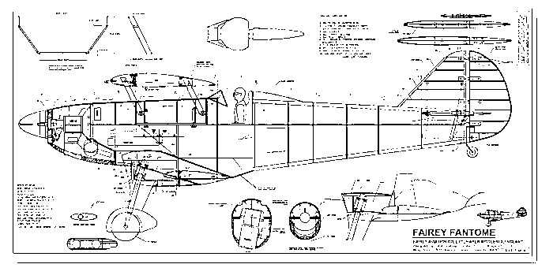](http://www.google.co.uk/url?sa=i&rct=j&q=&esrc=s&source=images&cd=&cad=rja&uact=8&ved=0ahUKEwi0tJu48pbNAhVLOMAKHdqXBp0QjRwIBw&url=http://www.rc-airplanes-simplified.com/large-scale-model-aircraft.html&psig=AFQjCNFn72UVi7RUqIi6Yx2Gn6HnzpkCYQ&ust=1465422497367722)

***I’d like you to imagine you are the Wright Brothers and you are using your scientific knowledge to design a machine, this does not have to be a flying machine! Think about what you have been learning in Topic about Lift, Thrust, Friction, Drag and Forces. Use your imagination, your machine might be to boil an egg, do the washing, drying and ironing, complete your homework, but it must use the scientific concepts we have been learning. How you choose to present your design is your choice. You may draw the design, make a poster, create a model, make it out of Lego or plasticine, you may even be able to make the mechanics. Have fun!***

***Where can your imagination and creativity take you?***

***Homework for Badger Class Summer Term***

***Assembly – 18th July 9:05***